Edinburgh College

Fitness to Continue to Study Procedure
Corporate Ref: SEP 012
Level: Three
Senior Responsible Officer: Assistant Principal Student Experience
Version: 1.2
EIA:
Approved by: SMT
Approved date: 15 August 2024
Superseded version: 1.1
Review date: August 2027

Version Control 3
1. Principles 4
2. Purpose 4
3. Types of Concerning Behaviour 5
4. Fitness to Continue to Study Process 5
Raising a Concern 5
Convening a Panel 6
Fitness to Continue to Study Panel Outcomes 6
Appealing the Outcome of a Fitness to Continue to Study Panel 7
Appeal Panel Meeting 7
5. Fitness to Continue to Study Flowchart 9
6. Appendix 1: Guide: How to Raise a Concern About a Student on Pro-Monitor 10
7. Appendix 2: Fitness to Continue to Study Invite Template Letter 11
8. Appendix 3: Outcome from Fitness to Continue to Study Panel 12
9. Appendix 4: Learner Agreement Template 14
10. Appendix 5: Appeal Invite Template Letter 15
11. Appendix 6: Appeal Outcome Template Letter 17
End of document 18

Version Control
Controlled version available on EC Intranet.
Version | Author | Date | Changes
1.1 | Safeguarding Team Leader | 22/01/2025 | Appendices 1 - 6 added
1.2 | Information Governance Manager | 28/01/2026 | Transferred to new template.

1. Principles
At Edinburgh College, we are committed to providing the best possible learning experience for all of our learners. Acceptance onto a course, and continuation on the course, is based on a reasonable expectation that a student will engage well in learning, teaching and assessment and that they will be successful in meeting the expected outcomes and success criteria for their course.

Edinburgh College has a duty of care to respond appropriately to situations where significant concerns about a student’s mental or physical wellbeing have been raised. This duty of care also applies not just to individuals but also to situations where there is a possibility of adverse impact or risk of harm to the wider College community.

This procedure should be applied in situations where signs of illness, declining mental health, emotional disorders, substance abuse or other personal issues have had an adverse impact on the ability of individual students to engage with their studies or has had an impact on the wellbeing of others in College.

2. Purpose
This procedure assists staff to address issues with confidence and promotes a positive attitude towards students who require support to help them achieve their educational goals. This procedure can be used as an alternative to the application of the Positive Behaviour Policy and Procedure, in cases where poor mental health and wellbeing is a consideration.

The purpose of this procedure is:
- To provide a consistent and coordinated approach to the handling of situations where a student’s behaviour is affected by their mental wellbeing, disability or health issue and disciplinary action is not appropriate
- To support the identification and implementation of reasonable adjustments
- To ensure appropriate support for colleagues and students who interact with or are affected by students in these circumstances

Students working towards qualifications where Fitness to Practice criteria need to be met must declare or accept support with any physical or mental health issues that may pose a risk to patient and/or public safety or their ability to carry out work placement activities safely. An example of this would be Health Care courses that require Scottish Social Services Council (SSSC) registration. If students can demonstrate effective management of their health condition, there should be no impact on successful completion of the course.

3. Types of Concerning Behaviour
Concerns about student’s fitness to continue to study may present in several ways whether on their own or in a combination. Some examples include:

• Emotional distress
• Decline in personal hygiene
• The sudden onset of mental or physical illness
• Signs or evidence of self-harming
• Drug or alcohol problems
• Regularly inconsistent or irrational behaviour or communication from the student
• Repeated interruptions of study

All fitness to continue to study will be assessed according to the individual circumstances. Though this procedure aims to work with students in a cooperative way, in some cases it may be deemed necessary and appropriate for the student to take a break from studies, or for the College to suspend or terminate the student’s studies.

If a concern about a student’s fitness to continue to study occurs while on placement, the College can discuss and consider alternative arrangements with the placement provider. If alternative arrangements are not possible, the student’s placement may be withdrawn, deferred or other arrangements made. This may have an impact on the student’s ability to achieve their award and may have future fitness to practice implications.

In implementing this procedure, the College maintains its commitment to its duty of care and any obligations towards students under the Equality Act 2010 and associated Public Sector Equality Duties, including the requirement to make reasonable adjustments.

4. Fitness to Continue to Study Process

Raising a Concern
Any Edinburgh College colleague can raise a concern around a student’s behaviour that may need to be considered under the Fitness to Continue to Study Procedure. Any instances of concerning behaviour must be reported to the student’s Learning Development Tutor (LDT), Course Tutor (CT) or Curriculum Team Manager (CTM) via ProMonitor. A CTM has responsibility, under the Procedure, to take forward all Fitness to Continue to Study actions. If a report is made to an LDT or CT, they should bring this to the appropriate CTM’s attention. See Appendix 1 for a guide on how to create a record an alert on ProMonitor.

Convening a Panel
A Fitness to Continue to Study Panel is convened by a CTM. If a Fitness to Continue to Study Panel is to be convened, a letter should be sent to the student by the CTM detailing the time, date and location of the meeting and who will be in attendance. The student should be given five working days’ notice of this meeting. The letter should also include an outline of the behaviour that is of concern and any supporting evidence/documentation gathered. See Appendix 2 for a Fitness to Continue to Study Invite Template Letter.

Any Fitness to Continue to Study Panel meeting will be chaired by a CTM. The Safeguarding team is not routinely involved in the Fitness to Continue to Study process but is able to support this process in the event where there is an immediate risk to life. The Safeguarding team can also offer advice to the Panel Chair throughout the process.

A student can invite someone along with them to support them during the meeting. Appropriate Student Experience colleagues may also be invited to attend and share concerns or support the student. The Panel Chair will be mindful that this is not a disciplinary process and ensure the number of staff invited to attend is kept to a minimum.

At the meeting, the student will be given the opportunity to respond to the points raised, ask questions, provide additional context and/or evidence and submit any details around extenuating circumstances. The Chair of the meeting may also ask follow up questions and for further details or clarification. Notes of the meeting will be taken and will be shared following the meeting.

After the meeting ends, the chair will outline their next steps, which may be time to consider the facts or to gather further information, and a timeline to communicate the outcome of the meeting. This should take no more than five working days and will be communicated in writing. See Appendix 3 for an Outcome from Fitness to Continue to Study Panel.

Fitness to Continue to Study Panel Outcomes
The potential outcomes from a disciplinary process are;
- No Further Action
- A Learner Agreement which may include specific actions, required engagement with College support services and a mandatory monitoring period
- Withdrawal from the course

See Appendix 4 for a Learner Agreement Template.

Appealing the Outcome of a Fitness to Continue to Study Panel
The student has a right to appeal any formal outcome from a Fitness to Continue to Study Panel. A formal outcome is considered to be withdrawal from the course only.

Students can appeal on the following grounds;
- Medical, personal or other circumstances which affected the student that the original panel were not aware of
- The process not being followed correctly
- New evidence which was not considered at the time of the original panel

The student must email the Assistant Principal Student Experience within five working days of receiving their Fitness to Continue to Study Panel outcome letter, indicating which of the three grounds they are basing their appeal on. The Assistant Principal will then set up an Appeal Panel and will share the information with the panel members.

The Appeal Panel Meeting outcome must be communicated to the student by the chair within five working days.

Appeal Panel Meeting
If an Appeal Panel meeting is to be held, a letter should be sent to the student detailing the time, date and location of the meeting and who will be in attendance five working days before the date of the meeting. The letter should also include an outline of the concerns raised and the student’s basis for appeal. See Appendix 5 for an Appeal Panel Invite Template Letter.

A student can invite someone along with them to support them during the meeting.

At the meeting, the student will be given the opportunity to outline their reasons for appeal and to present any further supporting evidence. The Chair of the meeting may also ask follow up questions and for further details or clarification. Notes of the meeting will be taken and will be shared following the meeting. The Panel Chair will be mindful that this is not a disciplinary process and ensure the number of staff invited to attend is kept to a minimum.

After the meeting ends, the Chair will outline their next steps, which may be time to consider the facts or to gather further information, and a timeline to communicate the outcome of the meeting. This should take no more than five working days and will be communicated in writing. See Appendix 6 for Appeal Outcome Template Letter.

The decision of the Appeal Panel is final. In the event that the student has concerns about how the College’s Fitness to Continue to Study Procedure has been applied, they may wish to complain using the College’s Complaints Handling Process.

5. Fitness to Continue to Study Flowchart

6. Appendix 1: Guide: How to Raise a Concern About a Student on Pro-Monitor

Open the Student’s PDR Pages.
- In the Meetings and Comments menu, select Learner Comments

- Select a user to be added to the FOA list from either the Select or Search lists and click the corresponding Add button.

- Click Add New
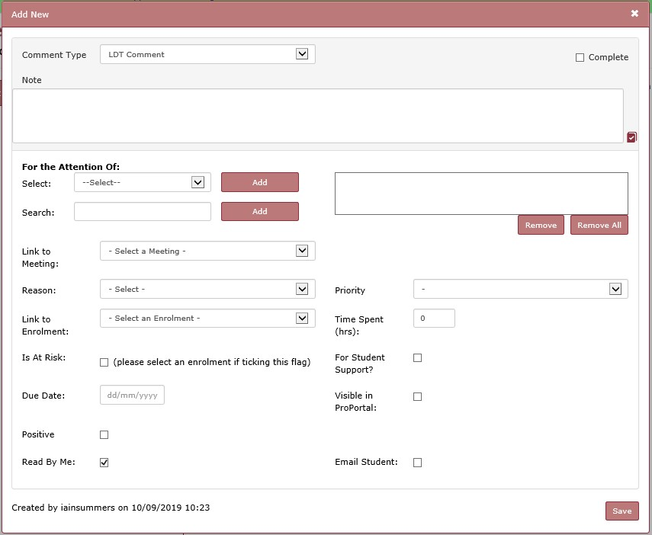
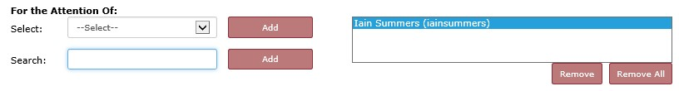

Editing the FOA list

Select
LDT Comment

Add
Note
s

Select a
Reason

If this relates to a particular
course, select the Student
Group

If relevant, add users to the
FOA list (see below)

Set Priority and any other
relevant flags

Click
Save

This contains any users associated with the student
–

Managers/Teachers
of the Student Group(s) or users in the Tutor Group(s) the student is in.

This allows you to search for any member of staff

Type (part of) the staff name and select from list

- To remove a user, select their name in the list, then click Remove.
Remove All will remove all the users from the list– no need to select them first.
NOTE - When users are added to the FAO list, they will be automatically be emailed by ProMonitor.
- The student is not emailed unless the Email Student box is ticked.


7. Appendix 2: Fitness to Continue to Study Invite Template Letter

DD/MM/YY
Dear Student Name,

FITNESS TO CONTINUE TO STUDY PANEL INVITE

I am writing to you to invite you to a Fitness to Continue to Study Panel meeting. This Panel is being convened because Edinburgh College colleagues have raised concerns about your wellbeing and your ability to engage with your studies.

The concerns that have been raised are;

Insert details of the behaviors/concerns that have been raised

You are invited to a Fitness to Continue to Study Panel meeting to discuss these concerns:

Insert date, time and venue of the hearing.

This meeting will be chaired by:

Insert name and title of the curriculum team manager, lecturer or team leader.

I would like to reassure you that this meeting is to discuss the concerns that have been raised and what support may be available to support you to succeed at College. My colleague, (insert colleague’s name and job title), will also be in attendance. I have enclosed the Fitness to Continue to Study Procedure for you to review ahead of our meeting.

You can bring along someone to support you at this meeting. You may also wish to speak to the Edinburgh College Students’ Association (ECSA) about this process, and to seek support and guidance from them during this process. https://ecsa.scot/contact

Yours sincerely,

Insert Name
Insert Job Role

your.name@edinburghcollege.ac.uk

8. Appendix 3: Outcome from Fitness to Continue to Study Panel

DD/MM/YY

Dear Student Name,

FITNESS TO CONTINUE TO STUDY PANEL OUTCOME

Following your recent Fitness to Continue to Study Panel Meeting on (insert date and time), I am writing to inform you that the outcome of the meeting is as follows:

- No further action
- A Learner Contract
- Withdrawal from your course

No further action. Following the previous meeting the decision has been made to end the Fitness to Continue to Study process and no further action will be taken.

A Learner Contract. The decision has been made to issue you with a Learner Contract. Your Learning Development Tutor/Course Tutor will be in contact to arrange a meeting to write up and agreed the Learner Contract. Engagement with this process is mandatory for you to continue with your studies.

If the outcome of the hearing is ‘withdrawal from your course’, the following text must be inserted:

Withdrawal from your course. Unfortunately, due to the serious concerns staff have raised that were discussed during the Fitness to Continue to Study Panel, the Chair has made the decision that the outcome of the meeting is to withdraw you from your course. This withdrawal is effective immediately.

I am sorry that this is the outcome of this process however, the concerns that have been raised are of such a significant nature that the Chair feels that there is currently no internal or external support available that could mitigate the impact that these concerns are having.

Any Bursary, EMA, Travel and/or Childcare funding you receive from the College will on (insert date). If you are in receipt of funding through the Student Awards Agency Scotland (SAAS), it is your responsibility to inform them of your withdrawal and failure to do so may affect future funding. The College can provide support to help you with these processes. If you are experiencing financial hardship, the College can support you to explore other, short term funding options, such as a Discretionary Fund payment. Your LDT or Course Tutor will be in touch with you to discuss your situation.

(All letters cont.)
You do have the right to appeal this decision and the process to appeal is included in the Fitness to Continue to Study Procedure, which I have enclosed with this letter. You can appeal for the following reasons;

- Medical, personal or other circumstances which affected the student that the original panel were not aware of
- The process not being followed correctly
- New evidence which was not considered at the time of the original panel

If you wish to appeal, please contact Anna Vogt, Assistant Principal Student Experience, via email at anna.vogt@edinburghcollege.ac.uk within five working days stating the reasons why. The Assistant Principal Student Experience will then write to you indicating a date, time and venue for an Appeal Panel Meeting and other related matters.

You have the right to invite someone along to support you at this meeting. You may also wish to contact the Edinburgh College Students’ Association (ECSA) to discuss this matter and seek further support and assistance. https://ecsa.scot/contact

Yours sincerely,

Insert Name
Insert Job Role

your.name@edinburghcollege.ac.uk


9. Appendix 4: Learner Agreement Template

Learner Agreement

All Learner Agreements should be uploaded on to ProMonitor and appropriate staff tagged to notify them that a Learner Agreement is in place. Subsequent review meetings should also be recorded on ProMonitor. A copy of this document should also be sent to the student via their EC email for their own records and for them to acknowledge their agreement with the Learner Agreement.

Student Name and EC Number
Course Name and Code
Staff Name
Discussion Topics

Student Goals and Agreed Actions

Agreed Action for College (including named staff members)
Dates for Review

10. Appendix 5: Appeal Invite Template Letter

DD/MM/YY

Dear Student Name,

REQUEST TO APPEAL

I am writing to acknowledge the receipt of your appeal in relation to the decision to withdraw you from your course following the Fitness to Continue to Study Panel meeting on (insert date).
Your appeal did not fall under any of the options available to you to appeal under. This means that your appeal will not be heard and therefore, the outcome of the Fitness to Continue to Study Panel stands.
You may wish to speak to the Edinburgh College Students Association (ECSA) for support and guidance on this process. https://ecsa.scot. Should you still wish to appeal the outcome of the Fitness to Continue to Study Panel, we will allow you one further opportunity to submit your appeal under the terms that you are allowed to appeal on.
OR
You have appealed this on the grounds that;
(delete as appropriate)
- Medical, personal or other circumstances affected you that the original panel were not aware of
- The process not being followed correctly
- New evidence which was not considered at the time of the original panel
The information you have provided in your appeal will now be considered by a panel chaired by the Assistant Principal Student Experience and you are invited to an Appeal Panel Meeting to discuss these matters on.
The Appeal Panel Meeting will take place on; (Insert time, date and venue)
The meeting will also be attended by;
(Insert the name of the Head of School/other panel members)You are entitled to representation at this meeting, and you may wish to speak to Edinburgh College Students Association (ECSA) for support and guidance during the process. https://ecsa.scot
The decision of the panel will be communicated to you within five working days of the Appeal Panel Meeting and the decision of the panel is final.

Yours sincerely,
Insert Name
Insert Job Role

your.name@edinburghcollege.ac.uk

11. Appendix 6: Appeal Outcome Template Letter

DD/MM/YY

Dear Student Name,

OUTCOME OF APPEAL

Following your recent Appeal Panel Meeting on (insert date and time), I am writing to inform you that the outcome of the meeting is that your appeal has been upheld/not upheld.

You appealed under the grounds that;
- Medical, personal or other circumstances affected you that the original panel were not aware of
- The process not being followed correctly
- New evidence which was not considered at the time of the original panel
The panel found that (insert details relating to information/appeal grounds and the decision around how these did/did not contribute to the appeal being upheld/not upheld).

The decision to withdraw you from your course following your Fitness to Continue to Study Panel will stands/has been withdrawn and you will be reinstated on your course with immediate effect.

The decision of the panel is final.

Yours sincerely,

Insert Name
Insert Job Role

your.name@edinburghcollege.ac.uk

End of document

