
Edinburgh College

Business Continuity Management
Framework
Corporate Ref: CDT2005
Level: 2
Senior Responsible Officer: Director of Communications, Marketing & Policy
Version: 3
EIA: 30/01/2026
Approved by: Audit and Risk Assurance Committee
Approved date: 4th March 2026
Superseded version: 2
Review date: March 2028
Version Control 2
1. Introduction 3
2. Framework statement 3
3. Business continuity management put into context 5
BCM and Risk Management 5
BCM and Critical Incident Management 5
4. The business continuity management lifecycle 2
Step 1: Analysis 2
Step 2: Design 3
Step 3: Implementation 4
Step 4: Validate 7
5. Business continuity management governance 8
End of document 8

Version Control
Controlled version available on EC Intranet.
Version | Author | Date | Changes
3 | Portfolio Manager | 04/03/2026 | Yearly review completed

1. Introduction
Business Continuity Management (BCM) provides Edinburgh College with a structured and proactive approach for preparing for, responding to, and recovering from major disruptive events that could adversely impact College operations. It ensures that essential services can continue or be restored quickly, even under challenging circumstances.
Disruptions may arise from internal events—such as the loss of key staff, the unavailability of a campus building, or a critical systems failure—or from external events, including severe weather, public health emergencies, or utility outages. Effective BCM enables the College to minimise operational, financial and reputational impacts arising from such incidents.
Edinburgh College has the following BCM objectives:
- Identify the major risk areas which could cause disruption to college operations.
- Establish defined plans to respond to critical incidents that cause a major disruption.
- Establish BCM arrangements to respond to all identified risks.
- Conduct regular reviews and table top exercises of BCM plans, to ensure plans remain accurate, effective, and are continuously improved.
- Increase BCM awareness across the College and ensure staff understand their roles and the plans in place.
- Work in partnership with other organisations to improve joint BCM planning, testing and review.

2. Framework statement
This Framework sets out how Edinburgh College strengthens its resilience to major disruptions by ensuring that critical systems and processes can be maintained or restored quickly, allowing business-as-usual operations to resume as soon as possible.
The Framework is built around four key steps, forming the Business Continuity Management (BCM) lifecycle:
Step 1: Analyse
Identify risks that could significantly disrupt College operations through structured risk assessments, recognised industry standards, and Business Impact Assessments (BIAs).
Step 2: Design
Develop Business Continuity Management (BCM) Plans that detail the College’s response to the identified risks and outline how essential services will be protected or recovered.
Step 3: Implement
Activate BCM Plans when responding to critical or major incidents.
Step 4: Validate
Evaluate BIAs and BCM Plans through lessons learned from real incidents, structured exercises, internal reviews, and audits. This validation cycle ensures continuous improvement of the College’s resilience arrangements.

Oversight of the BCM Framework and its associated policy is provided through established College governance arrangements, ensuring appropriate review, ownership, and approval at senior levels.

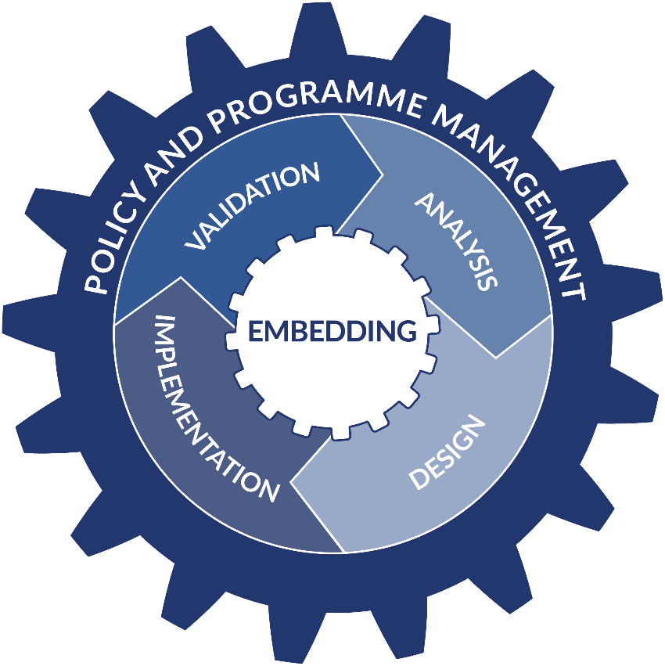

3. Business continuity management put into context

BCM and Risk Management
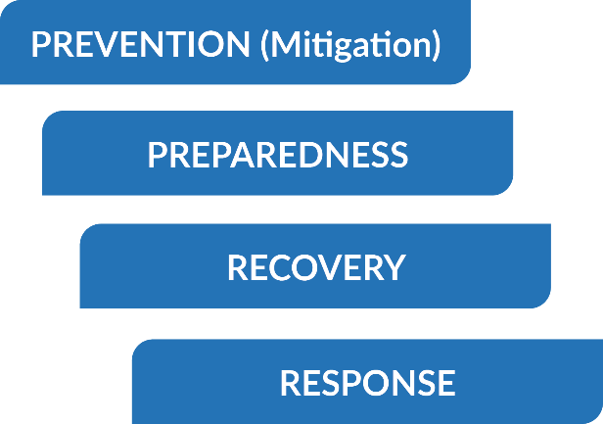
The College’s approach to BCM is closely connected to its approach to business risk management. Both disciplines share a common methodology focused on prevention, preparedness, response, and recovery, and both contribute to strengthening organisational resilience.
It is important to note that whilst similar, the two approaches are quite distinct. Risk management is concerned with minimising the probability and impact of a wide variety of risks relating to all areas of college business. Risk management alone will not completely prevent a critical or major disruptive event, as not every event is completely preventable. For example, adverse weather.
BCM therefore provides a dedicated, structured approach to preparing for, responding to, and recovering from significant disruptions that could affect the College’s critical services. It ensures that, when prevention is not possible, the College can still maintain essential functions, minimise disruption, and recover operations in a timely and coordinated manner.
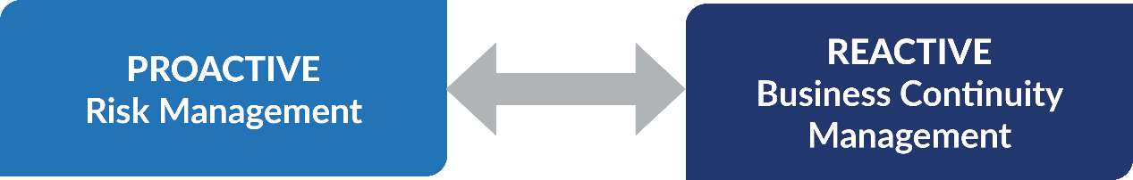

BCM and Critical Incident Management
While approaches to critical incident management (CIM), sometimes called emergency management, and BCM have overlapping interests, and both constitute reactive responses to major disruptive events affecting critical services, their primary goals are different.
CIM focuses on safeguarding people, property, and the College from immediate harm when a serious incident occurs. It is primarily tactical in nature and centres on rapid decision-making and immediate action to contain, stabilise, or stop the incident. CIM procedures are triggered at the point of incident, and the immediate priority is always life safety, incident containment, and preventing further escalation.
BCM, by contrast, is concerned with the restoration and continuity of critical services once the initial incident has been stabilised. It has a more strategic and longer-term focus, using pre-defined Business Continuity Plans to guide the College through maintaining essential operations and achieving a managed return to normal service.
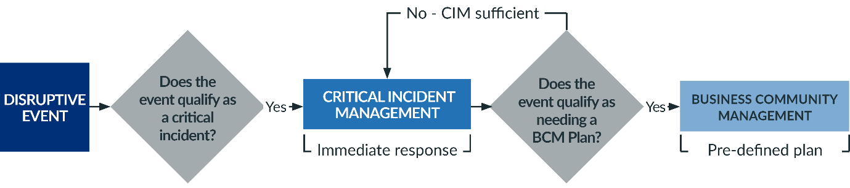
Importantly, a BCM plan cannot be activated until the incident has first been formally recognised and activated as a critical incident through the CIM process. Only once the immediate response has been initiated and stabilised does BCM come into effect, ensuring continuity of services and supporting the College’s sustained recovery.

The diagram on the next page demonstrates the relationship between the different elements of risk, critical incident and business continuity management, and their relationship to prevention, preparedness, response and recovery.

RELATIONSHIP BETWEEN RISK, EMERGENCY AND BUSINESS CONTINUITY MANAGEMENT
Prevention and Preparedness | Event | Response / Recovery
RISK MANAGEMENT  - H&S activity risk assessments  - Strategic risk management  - Operational risk management  Sound risk management practices should seek to identify, assess, communicate and mitigate any business disruption related risks.  PLANNING  - H&S Policy/Procedure/Guidance records  - Emergency Incident Policy and Procedure  - Testing/drills e.g. fire  - Critical Incident Management Policy Procedure  - Business Impact Assessments (BIA) to determine risks to college  - Business Continuity Plans (BCP)  - BCP testing/training exercises  - Critical Incident Report, including lessons learned  - Systematic review of policies and procedures  Planning should seek to build and maintain relationships and reinforce awareness of responsibilities. | Incident/Accident  - Low-level, routine incidents  - No significant disruption to operations  - Examples: minor injuries, near misses, low-risk hazards
  Routine Response  (BAU) | Non-Routine  Response | Recovery
  HEALTH AND SAFETY
  Incident and accident reporting via H&S portal – accessed via staff intranet
 | Emergency / Immediate Incident Response  - Incidents requiring immediate action to protect life and safety  - May involve emergency services  - Examples: fire alarm activation, medical emergency, security incident
  EVACUATION / EMERGENCY
  EC Evacuation and Emergency Procedure – accessed via H&S portal and RED folders at Reception/Boardrooms
 | Disruptive Incident/Event  - Significant incidents requiring coordinated, multi-team response  - Potential impact on people, operations, or reputation  - Requires escalation to senior leadership (SMT/ET)  - Examples: serious injury or fatality, major security threat, large-scale disruption
  CRITICAL INCIDENT MANAGEMENT (CIM)
  Critical Incident Management Policy and Procedure – accessed via Emergency and Critical Incident document hub on the staff intranet and RED folders at Reception/Boardrooms
 | Business Stoppage  - Major disruptions impacting critical services  - Focus on maintaining or restoring operations  - Invoked only after a Critical Incident is declared  - Examples: prolonged campus closure
  BUSINESS CONTINUITY MANAGEMENT (BCM)
  College BCM plans – accessed via Emergency and Critical Incident document hub on the staff intranet and RED folders at Reception/Boardrooms

4. The business continuity management lifecycle

Step 1: Analysis
The first stage of the BCM lifecycle is to gather, analyse, and evaluate information on the critical services delivered by each department and faculty, as well as services that operate College-wide. This analysis identifies the major disruptive risks that could affect those services and determines the potential consequences of a prolonged interruption.
This stage is informed not only by internal risk information, such as departmental risk registers and operational requirements, but also by industry standards, sector guidance, and external stakeholder recommendations, including input from emergency responders such as Police Scotland, local authorities, and national resilience partners. These external insights ensure that emerging threats, regional risks, and good practice in resilience planning are fully considered.
Business Impact Assessment (BIA)
The BIA is a comprehensive analysis of critical business functions or services, and is designed to provide a high-level indication of the possible impacts, associated timescales and subsequent resource requirements, in the event of a major disruptive event.
The BIA provides a high-level analysis of:
- the nature and severity of impacts,
- acceptable timescales for service recovery,
- resource requirements for maintaining or restarting operations,
- interdependencies between departments and external partners.
The output of the BIA informs the setting of Recovery Time Objectives (RTOs) and Recovery Point Objectives (RPOs) for each critical service and forms the foundation for developing appropriate Business Continuity Plans.
Definition of a critical function / Service
A critical function or service is one that meets one or more of the following criteria:
- Emergency Response Dependency:
The function underpins the College’s ability to respond to an emergency incident and take effective action to reduce, control, or mitigate its effects.
- Human Welfare or Environmental Impact:
Loss of the function could cause significant harm to staff, students, visitors, or the environment.
- Legal or Statutory Requirement:
The service is mandated by law or regulation, and failure to deliver it may result in sanctions, litigation, or regulatory intervention.
- Financial Impact:
Loss of the service would cause substantial financial loss, jeopardise funding, or create unsustainable operational costs.
- Reputational Damage:
Disruption or failure of the service would significantly damage the reputation of the College or erode stakeholder confidence.

Step 2: Design
Using the outputs from the BIAs completed in Step 1, Step 2 focuses on designing BCM Plans. These plans define:
- what actions must be taken,
- by whom, and
- within what timeframe
to ensure an effective response and recovery following a major disruptive event affecting critical functions or services.
There are three types of business continuity management plans used in the College:
- Departmental BCM plans (Tier 3: Operational)
These plans set out the actions required to respond to disruptions specific to a particular department, service, or operational area.
Examples include:
- response procedures for serious unplanned events in student accommodation,
- arrangements for securing alternative teaching facilities if core learning environments become unavailable.
- Corporate BCM plans (Tier 2: Tactical)
Corporate plans address major disruptions that affect multiple departments or College-wide services. These plans coordinate tactical responses and cross-college decision-making.
Examples include:
- College-wide responses to adverse weather,
- significant loss of ICT systems,
- major incidents affecting multiple campuses.
- Partner Agency BCM plans (External)
These plans address disruptive events that impact the College but where another organisation leads the response and owns the BCM arrangements.
Examples include:
- NHS-led plans for managing meningitis or other public health outbreaks,
- Police Scotland-led responses to major security incidents.
While the College does not own these plans, awareness and alignment of relevant College actions remain essential.
Plan Review and Approval
All Departmental and Corporate BCM Plans are reviewed by the Head of the owning department (or equivalent responsible lead) before progressing through the approval pathway:
- Risk Management and Assurance Group (RMAG) – initial scrutiny and endorsement
- Audit & Risk Assurance Committee – final approval
Once approved, all BCM documents follow the Edinburgh College Corporate Documentation Procedure prior to publication to ensure consistency, version control, and accessibility.

Step 3: Implementation
Implementation ensures that the College’s BCM arrangements are understood, accessible, and effectively enacted during both planned exercises and real incidents.
This stage has three key components: 1. Awareness and Access 2. Real Life Incidents, and 3. Training and Testing.
- Awareness and Access
Once BCM plans have been designed and approved, it is essential that staff across the College are aware of their existence and know how to access them when needed. Effective awareness and accessibility support rapid decision-making and help ensure that plans can be implemented without delay.
BCM plans are made available through multiple channels to ensure resilience and ease of access:
- Digital access: A full list of current BCM Plans is available on the College staff intranet and website.
- Physical access: Hard-copy emergency folders (“red folders”) containing all BCM plans are held in the Boardroom at each College campus (four locations). Hard copies are also held off campus by the Director of Communications, Marketing & Policy and the Portfolio Manager.
- Real Life Incidents
Implementation of BCM plans during an actual disruptive event represents the most realistic test of their effectiveness.
BCM activation is closely aligned with the College’s CIM process, which governs the initial tactical response to an emergency. A BCM plan cannot be invoked until a critical incident has been formally confirmed and activated through the CIM process. Once CIM actions have stabilised the immediate impacts, the BCM plan guides the sustained response and longer-term recovery.
Real-life events, while challenging, provide invaluable learning opportunities. Because they relate directly to the College’s day-to-day environment, lessons learned tend to be readily understood and adopted.
Following the activation of any BCM plan, a post-incident evaluation report called Critical Incident Report (also available on the staff intranet) must be produced. This report supports:
- identification of strengths and gaps,
- updates to BCM plans,
- wider organisational learning, and
- continuous improvement across the BCM framework.
- Testing / Training
Testing and training are critical steps in the implementation of BCM plans across the College. They are efficient ways to demonstrate how effective the developed BCM plans are, and how prepared the College is to respond to major disruptive events.
Testing and training also help find areas for improvement in BCM plans, which supports validation and continuous improvement of the approach to BCM in the College.
The table below provides guidance on the different approaches to testing and associated timescales. After each form of test some sort of evaluative report must be produced to assist with validation and continuous improvement.
APPROACH | WHAT IS INVOLVED? | BENEFITS/  CHALLENGES | SLA
Component Test | Confirming that a key procedure or piece of equipment that is relied on in an incident works. Could be as simple as checking that contact procedures work (e.g. checking phone numbers on an emergency contact list). | Benefits: Provides a more focused method of testing whether key procedures and equipment that are central to a plan are sound. Limited resources and time needed to implement this option. Enhances familiarity with the plan and encourages key people to question and challenge the assumptions made by getting them to think about real life scenarios.  Challenges: Limited to testing a discreet area of your plan – unlikely to test your plan in a holistic way. | Frequency: As required - scheduled testing, after component failure or if recommended after walkthrough, rehearsal or real-life incident.  Responsible: Component owner/s.
Walkthrough | A structured discussion involving key people responsible for responding to service disruptions. Involves discussion of how the team would respond in the event of different types of incidents. | Benefits: Enhances familiarity with the plan and encourages key people to question and challenge the assumptions made by getting them to think about real life scenarios.  Challenges: Limited realism of approach and there is a danger the team could digress into theoretical discussion. | Frequency: Min. once per calendar year for each Department and Corporate BCM Plan or when requested by SMT/ Exec Team.  Responsible: Plan owner
Rehearsal / Table Top | Key people who you rely on to respond to college disruptions rehearse their recovery, in real time, to an incident. People play set roles either as participants or as facilitators. The scenario is highly controlled, with use of a script to prompt interactions to strict timescales. | Benefits: A very realistic exercise type which provides a reliable test of the plan. It is dynamic, which ensures that lessons learnt and the value of business continuity is strongly reinforced. Highly effective form of training as this allows people to practice how they would respond to an incident in a way which is memorable.  Challenges: Resource intensive, requiring considerable time spent in planning and preparation as well as delivery of the event. Requires a number of people supporting the rehearsal who also require training to be able to carry this out. May involve short term disruption to business as usual. | Frequency: Min. once per calendar year for each Corporate BCM Plan.  Department BCM Plan rehearsals completed if/as required or requested by SMT/Executive team.  Responsible: SMT/ Executive team.

Step 4: Validate
Validation is the final stage of the BCM lifecycle. It ensures that BIAs, BCM Plans, and associated procedures remain accurate, relevant, and effective over time. Validation provides assurance that the College’s BCM arrangements are fit for purpose and continuously improving.
Validation draws on evidence from:
- real-life incidents,
- results of testing and training exercises (component tests, walkthroughs, tabletop exercises / rehearsals),
- lessons learned reports (part of the Critical Incident Report),
- internal audits,
- external partner feedback, and
- governance reviews.
By integrating these insights, the College ensures its BCM framework reflects evolving risks, operational changes, industry standards, and recommendations from specialist stakeholders (e.g., Police Scotland, NHS, local authority).

Business Continuity Lifecycle Flow Chart
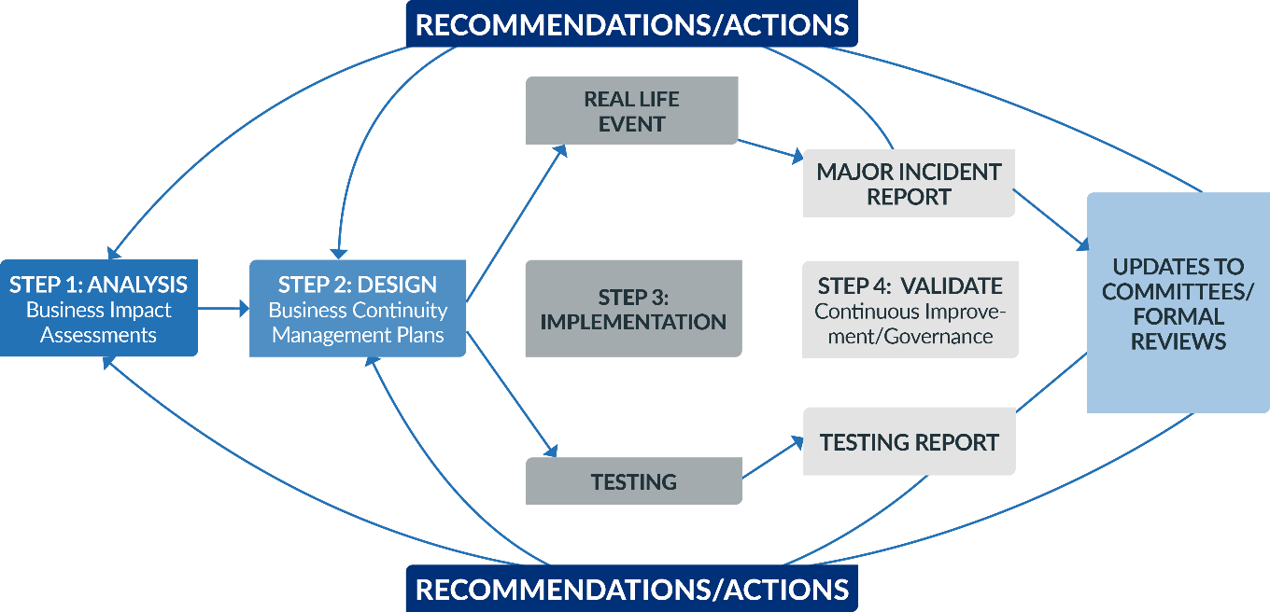
The diagram below demonstrates all four steps of the Business Continuity Lifecycle and the relationship between them all.

5. Business continuity management governance
Listed below are the various internal and external arrangements which provide good governance of the BCM framework and policy:
GROUP | BCM ROLES AND RESPONSBILITIES
Senior Management Team and key college service leads | Responsible for overseeing all BIA, BCM plans, implementation and validation activities at departmental level.
Risk Management and Assurance Group (RMAG)  Includes Executive and Senior Management Teams | Responsible for the corporate management and review of all BCM framework and policy matters within the College. Responsible for linking the BCM framework to the risk management arrangements within the College.  Responsible for authorising analysis, design, testing and validating BCM plans.
Audit and Risk Assurance committee + Board of Management | Responsible for strategic scrutiny and assurance of the BCM framework, BCM Plans, and ensuring internal controls are in place.
Internal Auditors | Responsible for providing an objective analysis and evaluation of the BCM framework and policy, BIAs and BCM plans, and proposing any consequent improvement actions.

End of document

