Edinburgh College

Student Attendance and Engagement
Policy and Procedure
Corporate Ref: SEP 015
Level: 3
Senior Responsible Officer: Assistant Principal Student Experience
Version: 1.1
EIA:
Approved by: SMT
Approved date: 15 August 2024
Superseded version: 1
Review date: August 2027

Version Control 3
1. Purpose 4
2. Attendance and Engagement 4
3. Potential Impact on Funding 4
4. Student Responsibilities 5
One Off Absences 5
Longer Term/Persistent Absence 5
5. College Responsibilities 5
6. How the College Supports Attendance and Engagement 6
End of document 8

Version Control
Controlled version available on EC Intranet.
Version | Author | Date | Changes
1.1 | Information Governance Manager | 22/01/2026 | Transferred to new template.

1. Purpose
Edinburgh College is committed to promoting a positive learning experience for all students, and a positive working environment for all.

Every student has the right to learn in a safe and supportive environment. We are committed to creating a culture of respect and responsibility that promotes positive behaviour. As part of our commitment to supporting all students, we have developed a Student Attendance and Engagement Policy and Procedure.

This procedure covers all enrolled students and should be read in conjunction with the Student Charter. The procedure lays out the process that may be applied by College staff where a student’s level of attendance and/or engagement is of concern. The procedure also details the type of action that may be taken to address different degrees of poor attendance or engagement.

2. Attendance and Engagement
Attending and engaging appropriately has a positive impact on the outcomes of all students and on the wider College community. It is expected that students will fully engage with the learning experience at Edinburgh College – this means attendance at timetabled classes and tutorials, and engagement with ongoing coursework and activities.

The College is committed to supporting students to attend and engage and acknowledges that this may look different for some of our students. Students are encouraged to be proactive about sharing any support needs or circumstances that may impact their attendance or ability to engage with appropriate staff, such as their Learning Development Tutor (LDT), Course Tutor, Learning Support Advisor or Guidance Officer.

3. Potential Impact on Funding
In order to receive full EMA, Bursary, Travel or Childcare payments students are required to attend and engage in all classes.

Where attendance falls below the expected level and a student has not engaged with the College to share the reasons for their absence, students should note that funding payments may be impacted or stopped, in line with rules set out by the College’s funding bodies.

4. Student Responsibilities

One Off Absences
It is the responsibility of the student to ensure that they attend, and engage with, timetabled classes. Where a student is going to be absent from one class or for the day, they should communicate with their lecturer and complete the Absence Form on MyEC. Students are then expected to engage with any course work or content that they have missed.

Longer Term/Persistent Absence
If a student is going to be absent for a longer period of time or on an ongoing basis, it is their responsibility to communicate this to their LDT or Course Tutor and share appropriate medical or professional evidence where required. Students are expected to be proactive with sharing any circumstances that may impact attendance or engagement so that, wherever possible, appropriate arrangements can be made to provide ongoing support.

5. College Responsibilities
The College has a responsibility to support the success of all students. For attendance and engagement purposes, these responsibilities include;
- Having an appropriate mechanism to support attendance and engagement
- Actively monitoring attendance and engagement levels through a variety of means
- Making reasonable adjustments and supporting students who face barriers to attendance and engagement, where appropriate
- Managing attendance and engagement issues where they fall below expected standards and impact progress. Where attendance and engagement levels fall below an acceptable level and mean that a student is no longer able to meet the outcomes of their course, we will support them to find an alternative destination, and ensure that College remains an option for the future.

6. How the College Supports Attendance and Engagement

Stage 1 – to be applied when a student’s attendance and/or engagement falls below the required levels to remain on track to achieve their qualification. This could look different, depending on the course and mode of delivery. Attendance and engagement levels for all students should be monitored as part of regular curriculum team meetings.

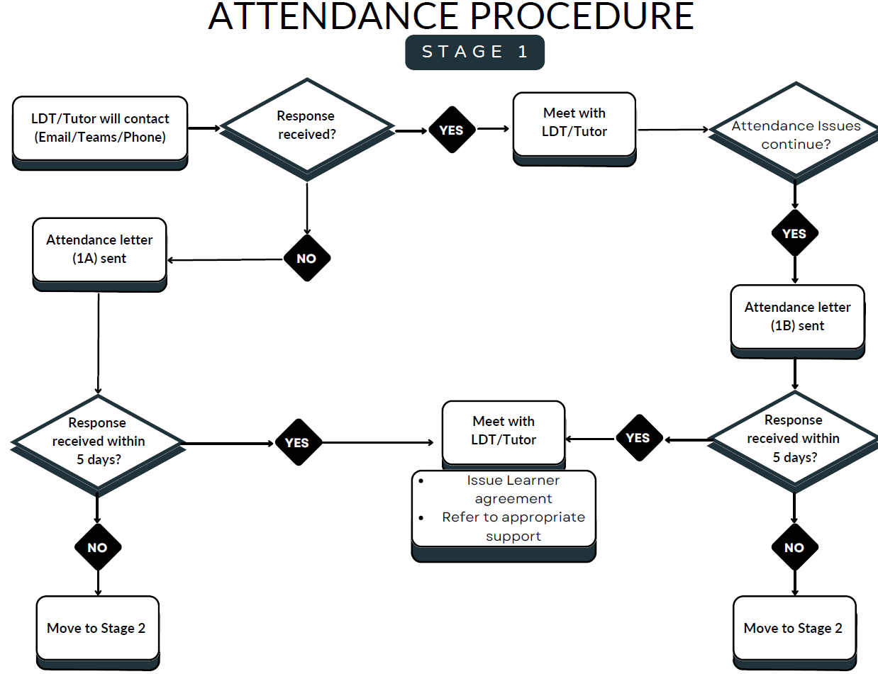

See Appendix 1 for Attendance Letter 1A
See Appendix 2 for Attendance Letter 1B

Stage 2 – to be applied when a student fails to engage with Stage 1 or if attendance and engagement does not improve following a Stage 1 meeting and agreed actions.

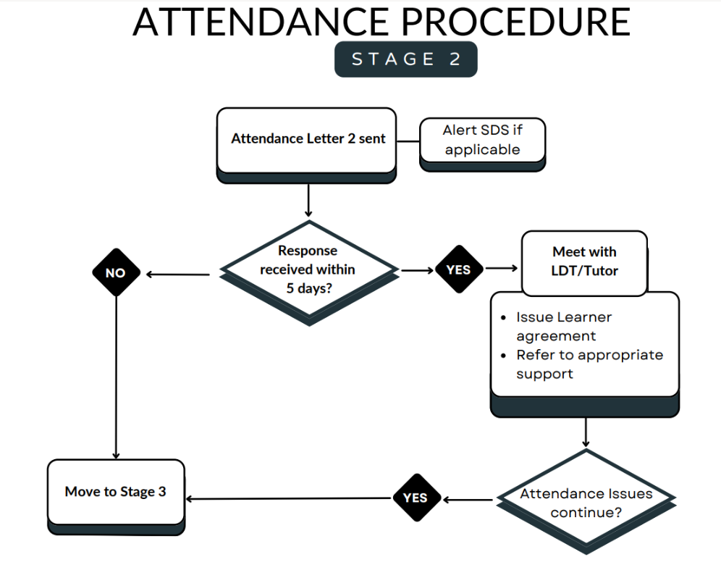
See Appendix 3 for Attendance Letter 2

Stage 3 – to be applied when a student fails to engage with Stage 1 or if attendance and engagement does not improve following a Stage 2 meeting and agreed actions.

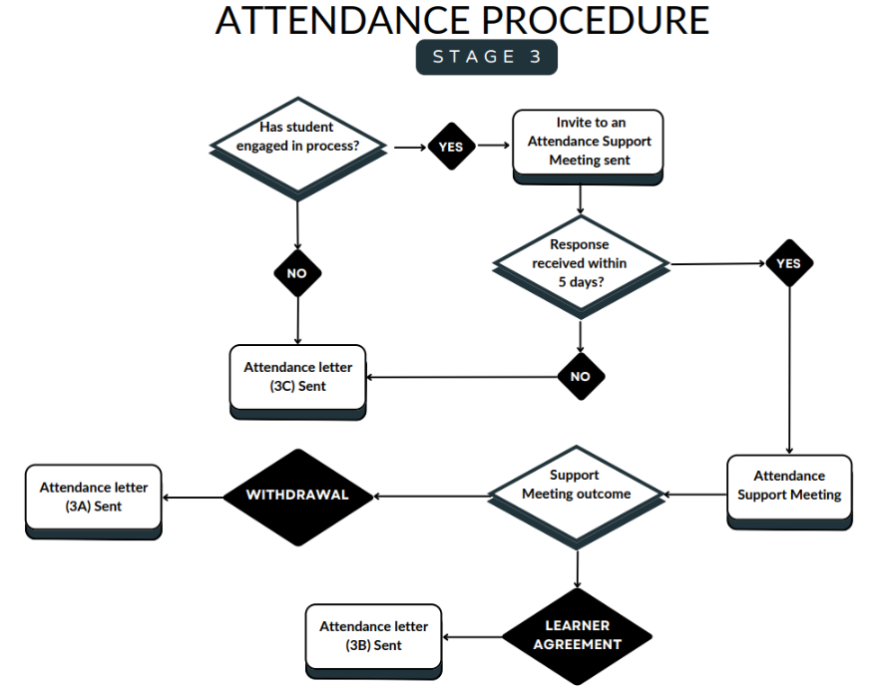

See Appendix 4 for an Invite to an Attendance Support Meeting (Stage 3 Only)
See Appendix 5 for Attendance Letter 3A
See Appendix 6 for Attendance Letter 3B
See Appendix 7 for Attendance Letter 3C

End of document

