|  |  |
| --- | --- |
| Corporate Ref. | Finance 5.2 |
| Level | Three |
| Senior Responsible  Officer | Director of Finance and Estate Infrastructure |
| Version | 11 |
| EIA | 16 November 2023 |
| Approved by | Chief Operating Officer |
| Approved date | 01 August 2025 |
| Superseded version | 10 |
| Review date | 01 August 2026 |

Tuition Fees

Policy

1. INTRODUCTION 2

2. PURPOSE 2

3. SCOPE 3

4. TUITION FEES BY CATEGORY 3

5. FEE WAIVERS AND CONCESSIONARY FEES 8

6. PAYMENT PLANS 9

7. DEPOSITS REFUNDS, AND WITHDRAWALS 10

8. RESPONSIBILITY 11

9. DISCRETIONARY ARRANGEMENTS 11

10. APPEALS 12

11. EFFECTIVE DATE 12

12. Appendix A 13

End of document 13

Version Control

|  |  |  |  |
| --- | --- | --- | --- |
| Version | Author | Date | Changes |
| 10 | Financial Accountant | 25/07/2024 | Update for period |
| 11 | Financial Accountant | 31/7/2025 | Minor updates for period |
|  |  |  |  |
|  |  |  |  |

# INTRODUCTION

This document details Edinburgh College’s policy on tuition fees.

New tuition fee rates apply for a full academic session beginning 1 August to 31 July in the following year. Fees are subject to an annual

revision and are due to be paid in full by students at the start of a course.

The College will waive the fees of any student entitled to support under the Scottish Funding Council’s (SFC) Fee Waiver Policy when studying an eligible course.

All other fees are payable in advance, unless funded by the Student Awards Agency for Scotland (SAAS) or Student Finance (England, Northern Ireland and Wales) with refunds issued in accordance with the policy outlined in section 7. In some circumstances there is the option of a payment plan.

The payment of fees is the responsibility of the student and, in the event of a student’s sponsoring authority (if any) failing to make payment, the student will be personally liable for payment. Where fees are not paid according to the College policy, credit control measures will be initiated in addition to withholding student results.

This Tuition Fees Policy excludes Educational Maintenance Allowances, Bursaries and Child Support which are covered by separate SFC policy documents.

# PURPOSE

This policy details the College’s approach to:

* The fee status and determination of students eligibility;
* Fee waiver and concessionary fees;
* Payment plans to pay by instalments; and
* Deposits, refunds and withdrawals.

# SCOPE

The College will ensure that the use of the policy for tuition fees including deposits, refunds and withdrawals represent fair and reasonable consideration towards students, and simultaneously protects the College from financial loss.

# TUITION FEES BY CATEGORY

**Fee status**

Edinburgh College tuition fees are charged at one of the rates indicated below, depending on the student’s fee status:

* Home – Scotland
* Home – RUK (Rest of the United Kingdom; England, Wales and Northern Ireland)
* International

In accordance with the relevant Fees Regulations, the tuition fee rate/s that students are charged depends on their nationality, immigration status in the UK, where they have been living and what they have been doing prior to the start of their course.

The ‘home’ fee rate is the rate currently applied to Scottish domiciled students and to applicable EU, EEA and Swiss nationals.

The ‘RUK’ fee rate is applied to students from elsewhere in the UK, however these fees are set at the same rates for ‘home’ students.

The International rate is set by Edinburgh College. The full-time Higher Education (HE) fee rate (for Higher National/sub-degree courses) is set by the Scottish Government and remains at £1,285.

The Further Education (FE) full time and part-time tuition fee rates remain at £1,008.

The Edinburgh College tuition fee table for 2025/26 is shown at Appendix A.

**Fee status determination**

The Scottish Government laid down the new Fee Status Regulations

in May 2022 as explained by the UK Council for International Student Affairs: [The Education (Fees) (Scotland) Regulations 2022.](https://www.ukcisa.org.uk/Information--Advice/Fees-and-Money/Scotland-fee-status) Additional information on Determination, Direction and FE Residency guidance can be accessed on the SFC website - SFC: [information for colleges.](https://www.sfc.ac.uk/our-funding/college-funding/student-support/)

You are Home-Scotland status if you normally live in Scotland or are ordinarily resident (i.e. your residence is not connected to undertaking a course of education) in Scotland at the start of the course.

You are Home-RUK status if you normally live in the rest of the UK but will become a resident of Scotland at the start of the course in order to undertake a course of education or remain a resident of another part of the UK.

* Brexit Guidance – EU Settlement Scheme EU, EEA and Swiss nationals and their respective family members who are living in the UK by the end of the transition period (31 December 2020) and continue to live here after that date have citizens’ rights under the EU Withdrawal Agreement, the EEA EFTA Separation Agreement and the Swiss Citizens’ Rights Agreement (“the Withdrawal Agreements”). Those who meet the conditions of the Withdrawal Agreements can continue to legally reside in the UK and enjoy associated rights. The rights of those who move to the UK after the end of the transition period (unless they have citizens’ rights as a family member of a person already in the UK) will be subject to new Home Office visa arrangements.
* Those who have citizens’ rights can apply for settled status via the Home Office’s EU Settlement Scheme (EUSS). They will be awarded:
* **Settled status** (i.e. indefinite leave to remain) if they have the requisite minimum of five years of continuous lawful residence in the UK, or
* **Pre-settled status** (i.e. limited leave to remain) if they have a shorter period of UK residence (any period of residence of less than five continuous years). After five years of continuous lawful residence in UK they can apply to change this status to settled status and should do so before their pre-settled status expires.

Please note – Those who have a family member that is an eligible person of Northern Ireland can also apply to the EUSS (regardless of whether the family member is an EU, EEA or Swiss citizen). To be eligible, the person of Northern Ireland must:

* Be a UK, Irish or dual UK/Irish national;
* Have been born in Northern Ireland;
* At the time of their birth, have at least one parent who held British, Irish or dual nationality (or was without any restriction on their period of residence);
* Be living in the UK by 31 December 2020.

The table below provides a summary of current fee status definitions but students should contact [international@edinburghcollege.ac.uk](mailto:international@edinburghcollege.ac.uk) or refer to ukcisa.org.uk for the latest updates:

|  |  |
| --- | --- |
| **Home – Scotland** | Students who normally live in Scotland and have British citizenship or ‘settled’ status (i.e. settlement, indefinite leave to remain) in the UK will have a fee status of Home – Scotland.   * Students must have been ordinarily resident in the UK for the 3 years prior to the start date of their course and the main purpose of that period of residence must not have been to receive full-time education. Certain categories of home student fees status require that the student is ordinarily resident in Scotland on the 1 August or 1 January closest to the beginning of the first term of their course.   The applicants below must all meet the residency conditions of 3 years in the UK, EEA or Switzerland and must be ordinarily resident in the UK at the start of the course.   * EU nationals and their family members living in the UK before the end of 2020 who have settled or pre-settled status. * Non-EU EEA and Swiss nationals and their family members living in the UK before the end of 2020 who have settled status, or are qualifying frontier workers who meet the existing migrant / frontier worker or self-employed conditions and have pre-settled status. * The children of former migrant workers where the child has settled or pre-settled status. * Family members of a relevant person of Northern Ireland living in the UK by the end of the transition period. * Irish nationals and their family members living in the UK before the end of 2020. * Irish nationals who move to the UK after the end of the transition period (31 December 2020). * Dual UK/Irish nationals living in Northern Ireland who exercised their EU residence rights before the end of 2020. * UK nationals and their family members living in the EEA or Switzerland on 31 December 2020 (or living in the UK immediately following a period of residence in the EEA or Switzerland). * Dual UK/EU nationals (within the personal scope of Article 10 of the EU Withdrawal Agreement) who are resident elsewhere in the UK who did exercise their EU residence rights. * Children of Turkish workers – both the child and the worker must have been ordinarily resident in the UK before the end of 2020. * Children of Swiss nationals where the Swiss national was living in the UK before the end of 2020 and has been granted pre-settled or settled status. * Certain other categories of students also qualify for Home student fee status depending on their nationality / UK immigration permission and ordinary residence. * In addition, in March 2022, the UK Government launched three immigration routes for Ukrainian nationals impacted by the conflict in their home country to resettle in the UK. Please contact [international@edinburghcollege.ac.uk](mailto:international@edinburghcollege.ac.uk) for more information. |
| **Home - RUK (England, Wales and Northern Ireland)** | Students who normally live in England, Wales and Northern Ireland and who have British citizenship or ‘settled’ status in the UK (but don’t meet any of the above mentioned ‘Home’ criteria) will have a fee status of Home - RUK and the fees will be the same as those for Home students. N.B Students must also meet the same ordinary residence requirements as Home-Scotland students. |
| **International** | For students holding a passport or national ID card from a country outside the UK who don’t meet either the Home or RUK definitions. UK national students without the relevant UK/EEA residency, or EU/EEA/Swiss nationals who do not have settled or pre-settled status under the EU Settlement Scheme, then the International rate will normally apply (unless they fall within one of the Home Student Fees category exceptions such as refugees). Students on a UK visa or Biometric Residence Permit with a time restriction / expiry date have limited leave to remain in the UK and do not have ‘settled status’. Such students will not normally qualify for fees at the Home-Scotland or Rest of UK rates unless they fall within certain specified circumstances as below. |

# FEE WAIVERS AND CONCESSIONARY FEES

This section details Edinburgh College’s approach to fee waivers and

concessionary fees.

Edinburgh College will waive the fees of any student entitled to support under the Scottish Funding Council (SFC) Fee Waiver Policy in respect of the activity of a student only if they meet all the relevant criteria in the policy. The policy generally focuses on the student’s circumstances rather than on the course of study.

Full-time and part-time students may be eligible for fee waiver grants for certain college courses provided they meet all the eligibility and residency criteria.

From academic year 2023-24, the College was able to allocate a fee waiver to students on all short full-time courses, where they meet eligibility criteria.

Fee waivers are generally not available to RUK or International students, however in exceptional circumstances fee waiver may be available. Please refer to the Fee Waiver Guidance in the student fee section of the [College website](https://www.edinburghcollege.ac.uk/information-and-advice/funding-and-fees).

Students will be asked to pay separately for any accommodation fees associated with their course.

Students must pay for any additional examination fees not already included as part of a standard tuition fee.

No concessionary rates are available to students.

Eligible courses are those whose fees are wholly covered by the fee waiver grant policy. Students taking two or more part-time courses will be eligible for a maximum of one full-time fee waiver. College fee waivers also arise where a student is not invoiced for fees for internal reasons such as (1) a staff member attending a course that has been approved by the Organisational Development team as part of their Individual Development Plan or (2) a student repeating a course or module due to an agreed failure by the College.

**Waived Fees**

Fees waived will be subject to the Fee Waiver Policy supported by the Scottish Funding Council (SFC). Each claimant (student) must meet the eligibility criteria per the Policy to render a claim as valid. The College provides fee waiver guidance for students and staff (based on the Scottish Funding Council Policy).

**Fee Waiver compliance**

Fee waivers can only be offered if candidates provide documentary evidence to prove eligibility for fee waiver funding.

# PAYMENT PLANS

The College policy is that students are required to pay their course

fees in advance of their course starting. Under specific circumstances, a student may be offered the option to pay fees by instalment, by setting up a payment plan. This option is only open to Home/RUK students. International students must pay 100% of fees prior to the College issuing an unconditional offer.

A payment plan can be arranged as per the schedule below. The first

instalment must be paid at least two weeks prior to the commencement of a course:

|  |  |
| --- | --- |
| **Total Fees Due** | **No of Instalments** |
| £250-£750 | 3 (With the first paid prior to the start of the course) |
| £751+ | 4 (With the first paid prior to the start of the course) |
| £1,008+ | 5 (With 25% as the first payment paid prior to the start of the course) |

Further details on how to set up a plan are available from the Finance Department: [Finance@edinburghcollege.ac.uk](mailto:Finance@edinburghcollege.ac.uk)

# DEPOSITS, REFUNDS AND WITHDRAWALS

**Deposits**

International students are required to pay 100% of fees prior to the

College issuing an unconditional offer. In very rare circumstances, and at the discretion of the College, alternative arrangements may be agreed. Both deposit and refund information for International applicants is provided at course enquiry stage, and is also available to view on the College’s International web page.

**Refunds**

Refunds will be only be issued as follows, and in accordance with the advertised SAAS funding cut-off dates:



|  |  |
| --- | --- |
| **For full-time and part-time courses:** | **For short non-full-time courses:** |
| * Full refund before the tuition fee cut-off date. | * Full refund if attend <25% of the course. |
| * 75% refund if <7 days post cut-off date (between 1st and 7th) | * No refund if attend >25% of the course. |
| * 50% refund if <14 days post cut-off date (between the 8th and 14th) |  |
| * 25% refund if <21 Days (between 15th and 21st); and |  |
| * No refund after 21 days post cut off. |  |

A 10% administration charge will be deducted on amounts paid before the cut off dates as detailed above. This is capped at £150. A full refund (100%) will be offered if a course in cancelled by the College. The Assistant Principal must inform the Director of Finance & Estate Infrastructure (or Finance Manager), and provide relevant course and student details. A full refund may be given if a written request is received for exceptional circumstances. Exceptional circumstances could include, for example, withdrawal from a course due to ill-health, or exceptional family circumstances.

Refunds for International students are only available where a visa application is made following Edinburgh College and UKVI immigration guidelines and if the visa application is unsuccessful. The request for a refund should be made in writing within 4 weeks of receiving the visa refusal. When a refund is confirmed, £250 of the deposit/fee will be retained by the College to cover administration costs. For full details of our refund policy for International students please contact [international@edinburghcollege.ac.uk](mailto:international@edinburghcollege.ac.uk).

**Withdrawal from a course**

Where a student withdraws or is withdrawn by the College for non-attendance or non-submission of course work they will be liable for any outstanding fees.

In exceptional circumstances a student may withdraw from a course

and be eligible for a refund as above.

# RESPONSIBILITY

The Chief Operating Officer, in conjunction with the Director of Finance & Estate Infrastructure are responsible for managing this policy.

Relevant members of the Finance team, the Curriculum teams, and International team are responsible for the effective operation of this Policy and Procedures.

# DISCRETIONARY ARRANGEMENTS

In exceptional circumstances, normally on the advice of the Chief Operating Officer, this policy may be over-ridden at the discretion of the Principal.

# APPEALS

Students have the ability to appeal in accordance with the Student Appeals Policy and Procedures.

# EFFECTIVE DATE

This policy and procedure became effective from 1 August 2025 as agreed by:

Signed Date……01/08/2025……

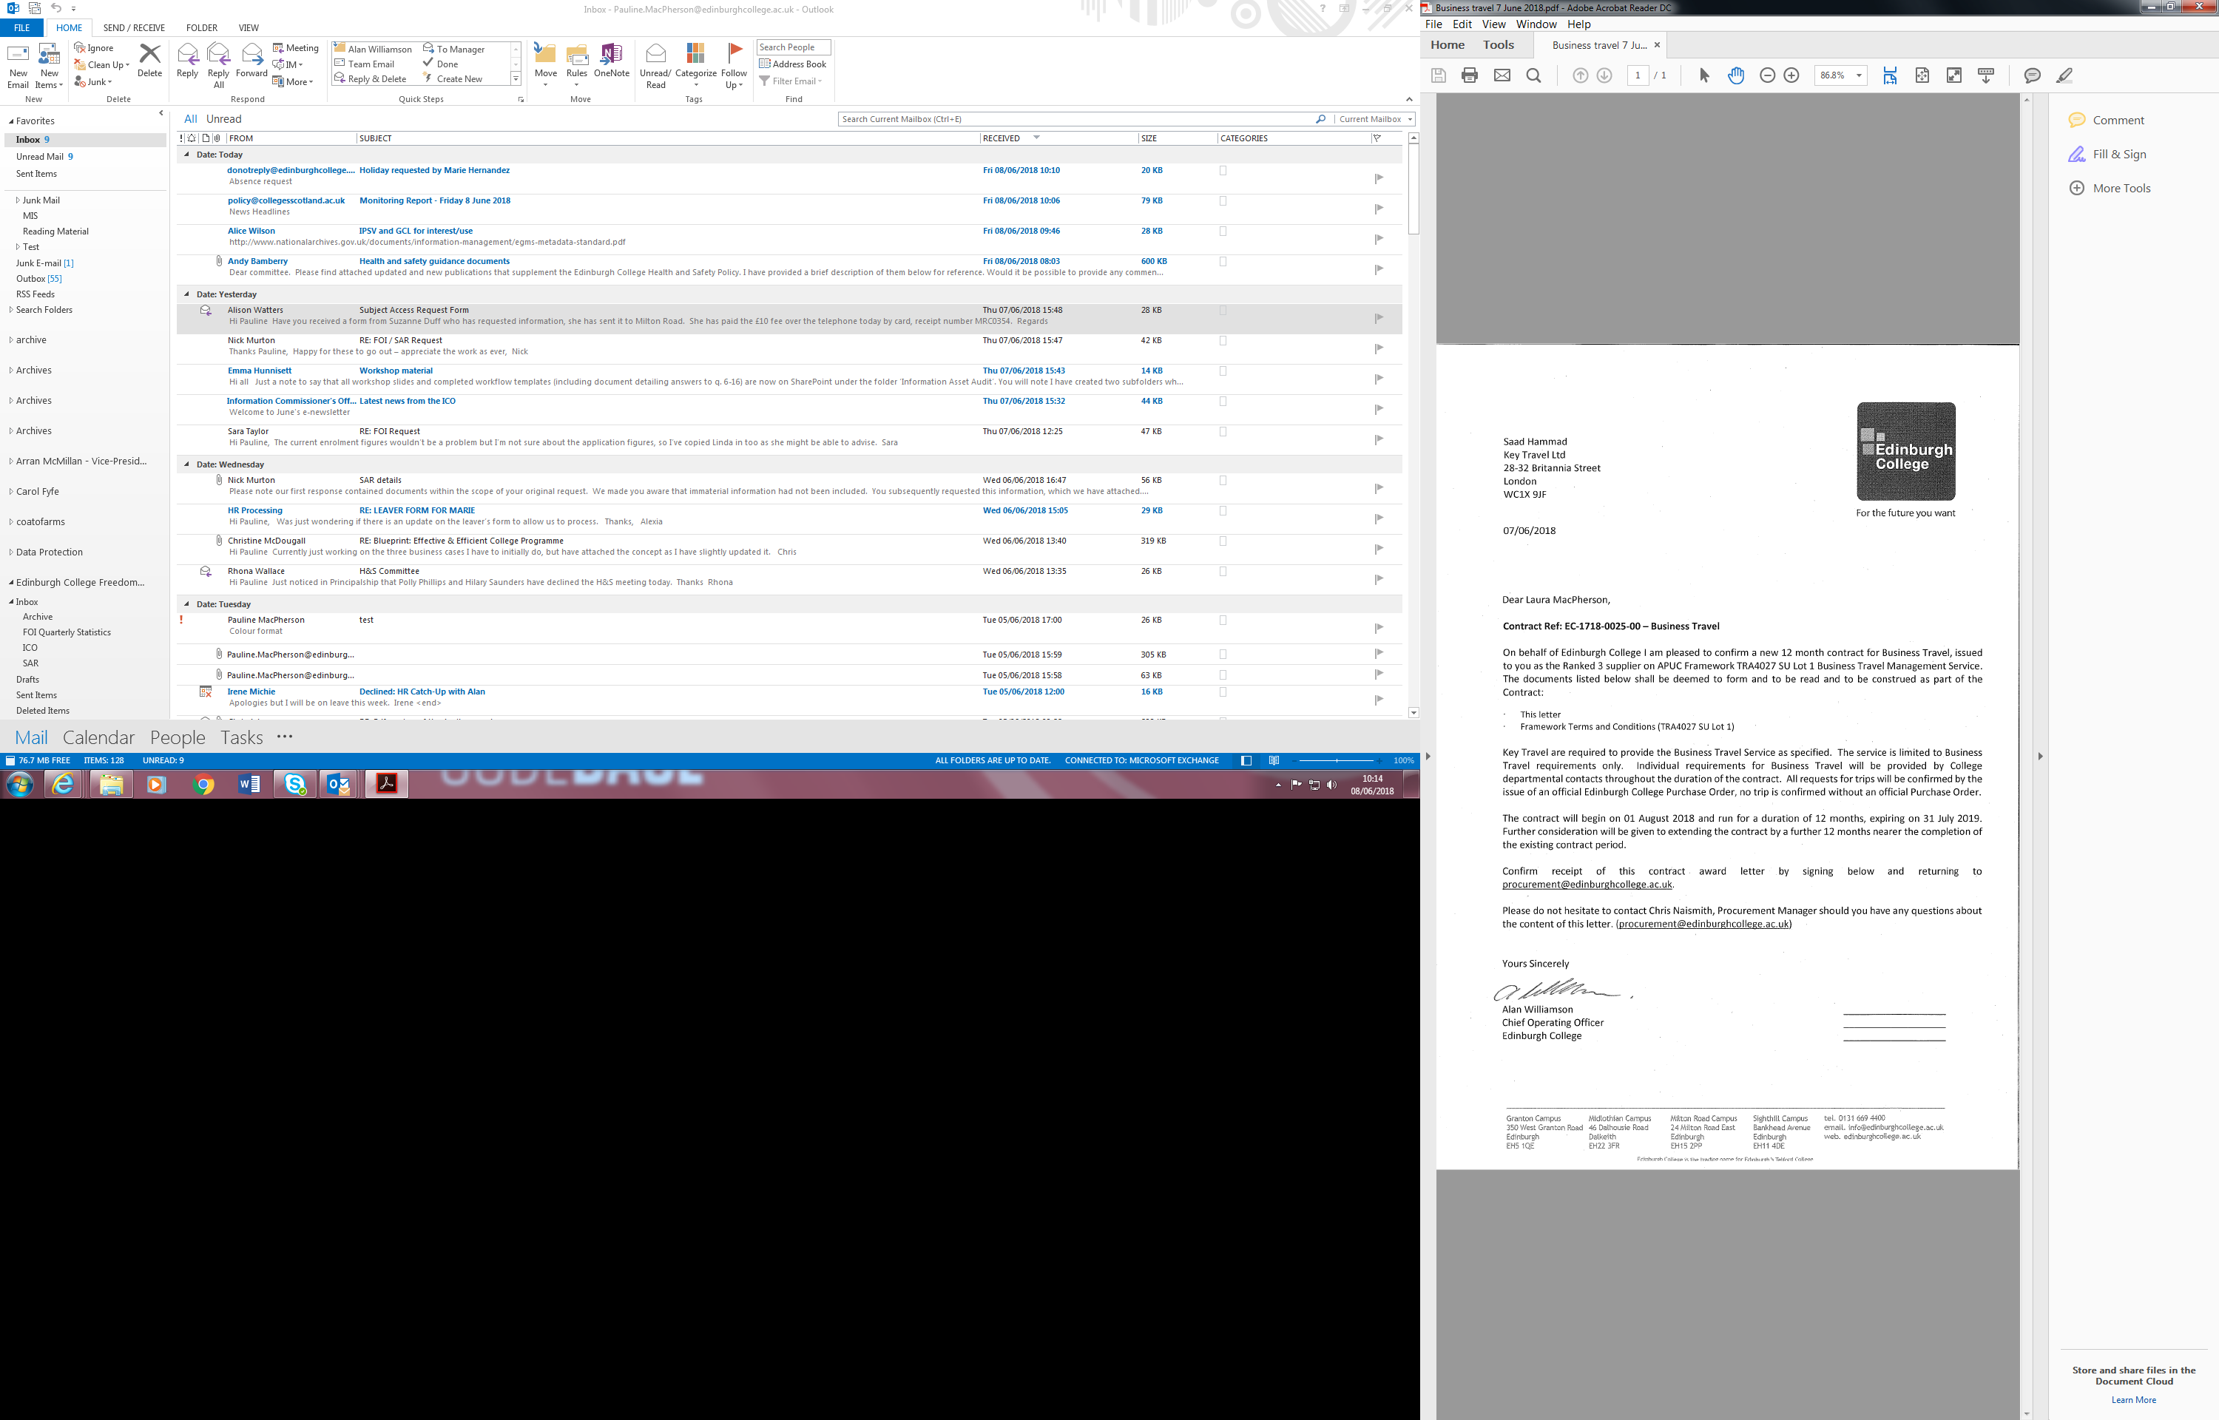

Alan Williamson, Chief Operating Officer

(For and on behalf of College management).

# Appendix A

|  |  |  |  |  |  |
| --- | --- | --- | --- | --- | --- |
| **Tuition/Examination Fees for Session 2025/26** | | | | | |
|  |  | **2024/25** | | **2025/26** | |
|  |  | **Home-Scotland/Home**  **-RUK** | **International** | **Home-Scotland/Home -RUK** | **International** |
|  |  | **£** | **£** | **£** | **£** |
| **Full-Time** |  |  |  |  |  |
| Advanced (HNC/HND)  (SAAS/Self Paying/Sponsored) |  | 1,285 | 8,400 | 1,285 | 8,400 |
| HNC Fast Track – 1 Semester |  | - | 5,700 | - | 5,700 |
| Non-Advanced (FE)  (Waiver/Self Paying/Sponsored) |  | 1,008 | 7,900 | 1,008 | 7,900 |
| Degree |  | 1,820 | 8,600 | 1,820 | 8,600 |
| Non-Advanced (FE) 1 Semester |  | - | 3,950 | - | 3,950 |
| UAL Foundation Diploma in Art & Design |  | - | 8,400 | - | 8,400 |
| **Part-Time** |  |  |  |  |  |
| NQ Higher (Day or Evening) |  | 355 | 1,450 | 366 | 1,677 |
| Per Credit |  | 120 | 330 | 124 | 330 |
| Per Half Credit |  | 60 | 165 | 62 | 165 |
| College Based General English ESOL (SFT) |  | 504 | - | 504 | - |
| for CbESOL National 5 and Higher – (Evening) |  | 200 | - | 200 | - |
| College Based General English ESOL |  | 308 | - | 308 | - |
| College Based General English ESOL  (Evening) |  | 246 | - | 246 | - |
| Community Based General English ESOL |  | 77-340 | - | 77-340 | - |
| Community Based General English ESOL  (Evening) |  | 175 | - | 175 | - |
| Resits per credit (with tuition) |  | 120 | - | 124 | - |
| Resits (without tuition) |  | 50 | - | 50 | - |

# End of document